**Task1 – Apps for Mobile Devices/Sensors**

**Team Members:**

Sindhu Koneru

Sujitha Onteru

Prathyusha Dinne

Anudeep Vattipalli

Roopesh Utukuri

**Application 1 – Sensor Tag:**

When mobile user runs this app and moves sensor tag is moved rapidly it generate X,Y and Z coordinates of the tag. These coordinates are displayed in logcat.

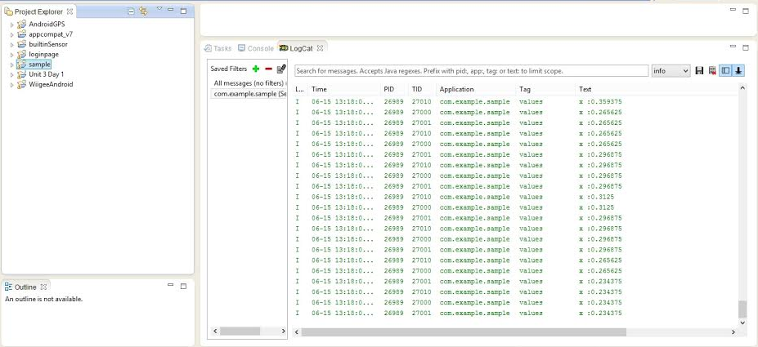

**Application 2 - Android Motion Sensor:**

This app recognizes mobile motion and displays color according to its axis. It displays red and green color screens.

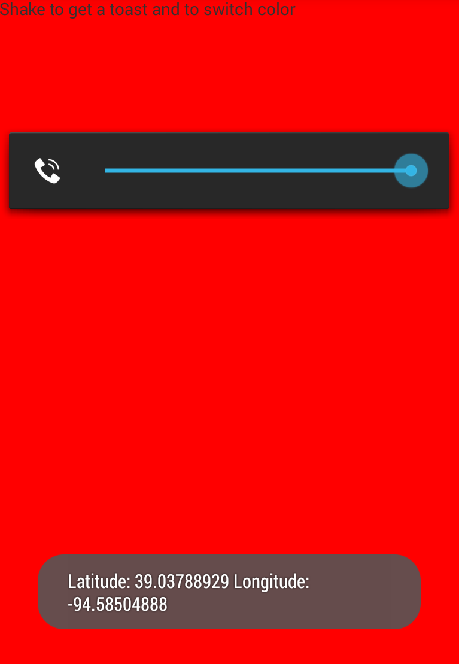

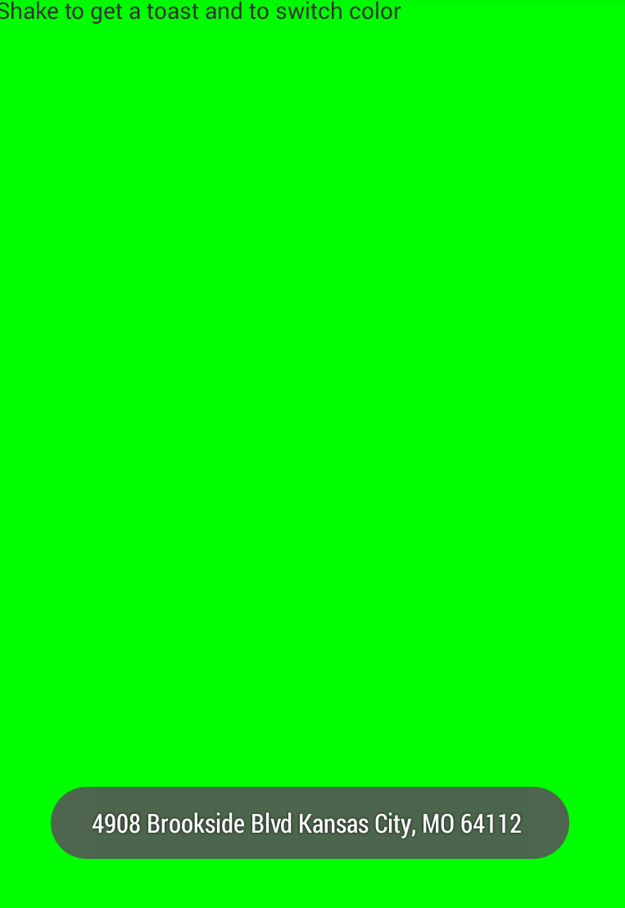

**Application 3 – Android GPS:**

This application on successful run displays latitude & longitude location using the sensor tag and thus recognizes physical address of it. For this application to run, we had to install android 4.3 and above in SDK and also include google API in jar files.

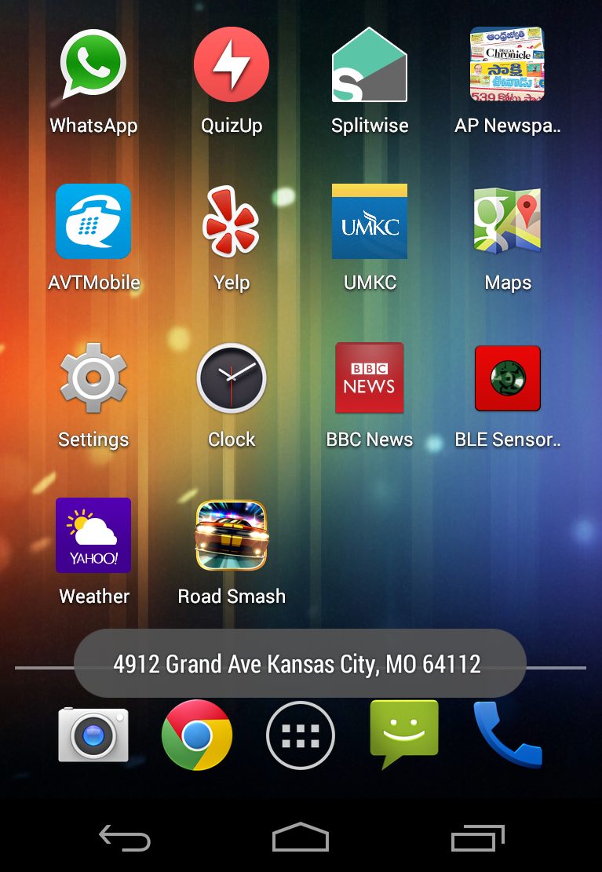

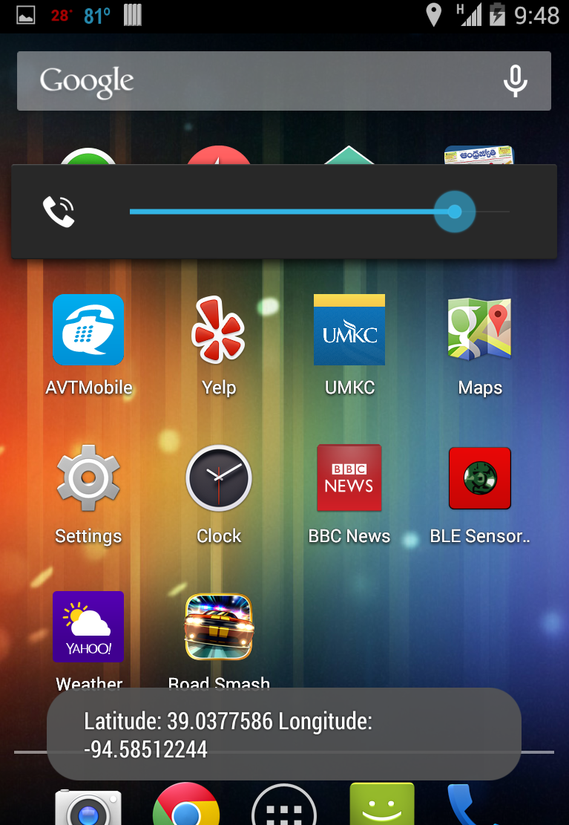

**Application 4 – Android Wigee:**

This application will ask user to recognize any gesture movement upon running mobile app and the user needs to save any particular gesture. After which through a component ‘gesture recognition’ user can perform any gesture movement and verify whether this gesture is same what he/she has saved using ‘save gesture’. If this gesture is same as the saved one, then a message probability 1.0 is displayed else 0.0. We need to remove pre included wigee jar file and private libraries.

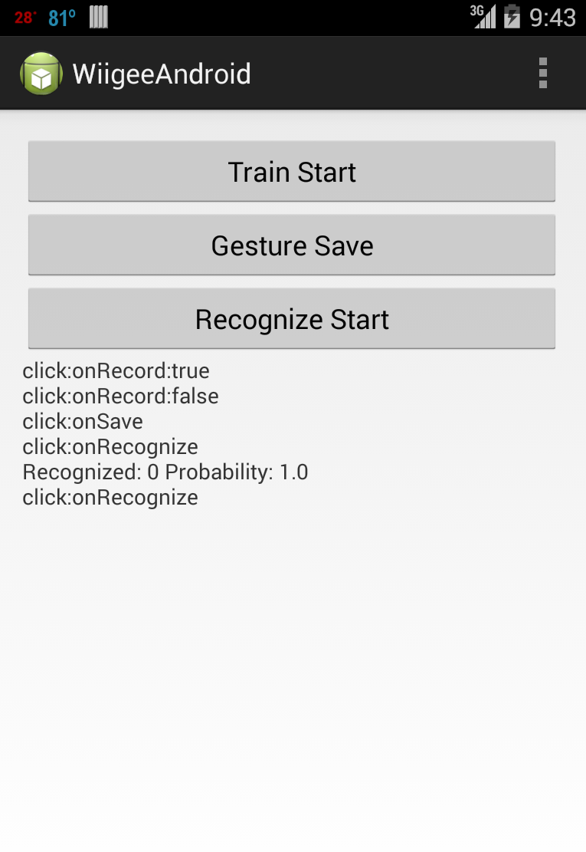

**Application 5 – Chronos Watch:**

This app is basically a gaming interaction for the user. User need to wear this chronos watch and throw punches in the air. Total number of punches punched and the most power packed punch will be displayed to the user.

